Portable access ramp
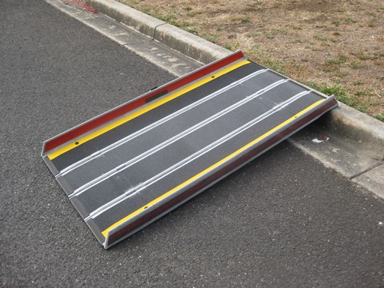
Free hire
Available from
Moyne Shire Council Office
1 Jamieson Avenue
Mortlake

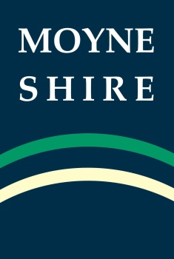
This is a free service provided by Moyne Shire Council. For further information please phone (03) 5558 7888.

